CSE 211 — Theory of Computation
Introduction · Simplifying CFGs · Chomsky Normal Form · CYK
Lesson notes · Exam approach · TF practice with solutions · Quick notes (Atif Sir's portion)

How to Read These Notes
EXAM FOCUS | Exam importance, where it appears in the TF collection
MEMORIZE | Rules, tables and formulas to memorize
TRAP | Common mistakes and exam traps
EXAM-READY ANSWER | Model wording you can write in the exam
NOTE | Extra explanation / clarification
Grey box, monospace | Code, worked tables, derivations and hand-drawn sketches
Centered grey box | Formula to remember / final numerical result
Purple heading / ✔ green | Practice questions / their solutions

Contents
Exam Map — What the TF Papers Ask — a 15-mark CNF or CYK question in every recent paper
Lesson 1 — The Three Areas and the Course Plan — automata, computability, complexity; models of computation
Lesson 2 — Simplifying Grammars — useless symbols, ε-productions, unit productions
Lesson 3 — Converting to Chomsky Normal Form — the 4-step order, terminals → variables, breaking long bodies
Lesson 4 — The CYK Membership Algorithm — triangular table, X_{ij}, worked tables
Quick Notes — Intro & CNF — revision bullets + key diagrams
NOTE Slide numbers refer to the PDF pages of Lecture - 1 (intro_2).pdf (14 pages) and Lecture - 2 (cnf).pdf (35 pages). Atif Sir follows Hopcroft–Motwani–Ullman. Every CNF conversion was checked by a program (same language as the original grammar on all strings up to length 7–8) and every CYK table was generated by a program. Practice provenance: Actual = taken from a TF paper; Adapted = TF question with changed details; Constructed = new question in TF style.

Exam Map — What the TF Papers Ask
Session | CNF / CYK questions
2023-24 | Q6 CYK: is 0010 in L(G) (S→BZ|CY|ZZ|YY …)? Describe L(G) (15)
2022-23 | Q7 CYK: is 0100 in L(G), S→AB|AY|YA|1, A→ZA|YA|0|1, B→YA, Z→0, Y→1? (15)
2021-22 | Q5 Convert S→A1A|B, A→0A|1A|ε, B→1 to CNF (15)
2020 (Jan term) | Q7 CYK: is 10011 in L(G), S→BZ|CY|ZZ|YY, B→ZA, C→YA, A→ZA|YA|0|1, Z→0, Y→1? (15)
2019-20 | Q7 CYK: is 01100 in L(G) (S→BZ|CY|ZZ|YY …)? Describe L(G) (15)
2017-18 | Q7(a) Convert S→A1A|B, A→0A|1A|ε, D→00 to CNF (8) · Q7(b) CYK: is 01101 in the language of the CNF grammar of 7(a)? (7)
2016-17 | Q6(b) Convert A→BAB|B|ε, B→00|ε to CNF (10)
2014-15 | Q5(c) CNF definition; convert A→BAB|B|ε, B→00|ε to CNF (9⅓)
2008-09 | Q2(a) S→ASB|ε, A→aAS|a, B→SbS|A|bb: eliminate ε-productions (7⅓) · Q2(b) Same grammar: eliminate unit productions (8) · Q2(c) Same grammar: eliminate useless symbols (8)
2007-08 | Q13 CNF definition; CYK for 'abaab' with S→AB|BC, A→BA|a, B→CC|b, C→AB|a (10)

EXAM FOCUS A full 15-mark CNF or CYK question in every paper since 2017-18 (2023-24, 2022-23, 2021-22, 2019-20, Jan-2020, 2017-18). The CYK grammar S → BZ | CY | ZZ | YY … was set three times (2023-24, 2019-20, Jan-2020) with a different string — learn Lesson 4's table method and the language of that grammar. CNF conversion of S → A1A | B, A → 0A | 1A | ε came twice (2021-22, 2017-18) and A → BAB | B | ε, B → 00 | ε twice (2016-17, 2014-15).

Lesson 1 — The Three Areas and the Course Plan
Lecture 1, slides 1–14
Theory of computation has three areas linked by one question — what are the fundamental capabilities and limitations of computers? (sl. 2–3): automata (DFA, NFA, CFG, PDA — mathematical models of machines), computability (decidability: what can or cannot be solved), complexity (tractability: what can or cannot be solved efficiently — P, NP, NP-complete, NP-hard, PSPACE). 'Computer science is no more about computers than astronomy is about telescopes' (Dijkstra, sl. 4); computability is like asking whether we can exceed the speed of light rather than how to build faster vehicles (sl. 5).
Model | Memory | Power / use (sl. 6, 11–13)
Finite automata (DFA, NFA) | limited — finite states | regular languages; compilers (lexers), hardware control units; cannot do 0^n1^n
Context-free grammars / PDA | a stack | context-free languages; parsers, AI, linguistics
Turing machine | unbounded tape | can simulate a computer; what a TM cannot solve is beyond computation

Alan Turing proposed the Turing machine, helped break Enigma and proposed the Turing test (sl. 7). Syllabus (sl. 8–10): regular languages, context-free languages, Turing machines and their equivalence with a computer, decidability, time and space complexity. Textbook: Hopcroft, Motwani & Ullman; references Sipser and Lewis & Papadimitriou (sl. 14).
NOTE No TF question has come from this lecture. The ToC-in-the-world questions (passwords, cryptography, hard problems) are answered in Hakim Sir's Intro note, Lesson 1.

Lesson 2 — Simplifying Grammars
Lecture 2, slides 19–30

1. Useless Symbols (sl. 22–23)
X is generating if X ⇒∗ w for some terminal string w (every terminal is generating). X is reachable if S ⇒∗ αXβ. X is useful if it is both, i.e. it appears in some derivation of a terminal string from S; otherwise useless. Find generating symbols inductively (terminals; then any A with a body of generating symbols), delete the non-generating ones, THEN find reachable symbols from S and delete the rest.
S → AB | a, A → b B is not generating → delete S → AB: S → a, A → b
A is not reachable → delete A: S → a (sl. 23)

TRAP Order matters: generating first, then reachable. In the other order a symbol made unreachable only by deleting a non-generating production would survive (here A).

2. ε-Productions (sl. 24–26)
A is nullable if A ⇒∗ ε (basis: A → ε; induction: A → C1…Ck with all Ci nullable). For every production with nullable symbols in its body, add all versions with any subset of those symbols removed (but never add A → ε). If the language contains ε, keep S → ε (Hopcroft: the grammar is then 'CNF + S → ε').
S → AB, A → aAA | ε, B → bBB | ε nullable: A, B, S
S → AB | A | B, A → aAA | aA | a, B → bBB | bB | b, and add S → ε (S nullable) (sl. 25–26)

3. Unit Productions (sl. 27–30)
A unit production is A → B (both variables). (A, B) is a unit pair if A ⇒∗ B using unit productions only ((A, A) by zero steps). For each unit pair (A, B) add A → α for every non-unit production B → α; then drop all unit productions.
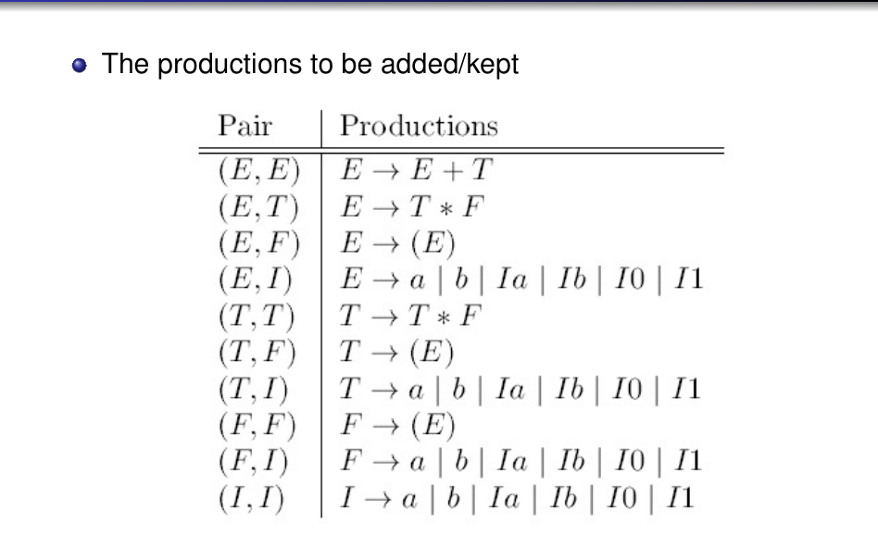
Figure 2.1 — Unit pairs and the productions kept for E/T/F/I (sl. 29)

Exam Approach
1. List nullable variables; rewrite every production (all subsets); note whether ε ∈ L.
2. List unit pairs (closure); replace unit productions.
3. Remove non-generating, then unreachable symbols.
4. Show the grammar after each step — the marks are per step.

Practice — Lesson 2
(a)–(c) Actual — 2008-09 Q2(a)–(c).
(a) For S → ASB | ε, A → aAS | a, B → SbS | A | bb eliminate ε-productions. (7⅓)
(b) Eliminate unit productions. (8)
(c) Eliminate useless symbols. (8)

✔ Solution
(a) Nullable: S only (A and B always produce a terminal). Remove S from bodies in all ways:
S → ASB | AB
A → aAS | aA | a
B → SbS | Sb | bS | b | A | bb (ε ∈ L, so the language is L(G′) ∪ {ε}; keep S → ε separately if required)

(b) Unit pairs: (S,S), (A,A), (B,B), (B,A). Replace B → A by A's non-unit bodies:
S → ASB | AB
A → aAS | aA | a
B → SbS | Sb | bS | b | bb | aAS | aA | a

(c) Generating: a, b; A (A → a); B (B → b); S (S → AB). All generating. Reachable from S: A, B (and a, b). No useless symbols — the grammar of (b) is final. (Both steps were checked: the language is unchanged on all strings up to length 6.)

Lesson 3 — Converting to Chomsky Normal Form
Lecture 2, slides 2–3, 19–21, 31–35
MEMORIZE CNF: every production is A → BC (two variables) or A → a (one terminal), and there are no useless symbols (sl. 2). Every non-empty CFL without ε has a CNF grammar; with ε, add S → ε (S not on any right side). Order (sl. 21): (1) eliminate ε-productions, (2) eliminate unit productions, (3) eliminate useless symbols, (4a) put terminals of long bodies into new variables (A → a), (4b) break bodies of length ≥ 3 into chains.

1. Steps 4a and 4b — Worked Example (sl. 32–35)
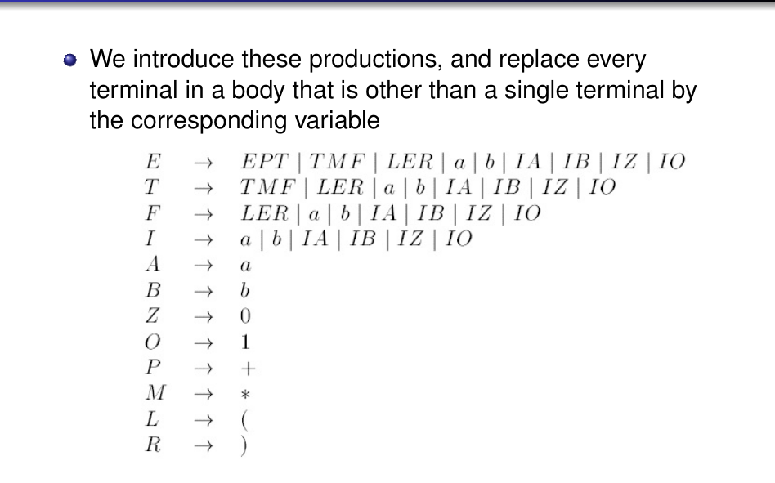
Figure 3.1 — Replacing terminals in long bodies by new variables (sl. 34)
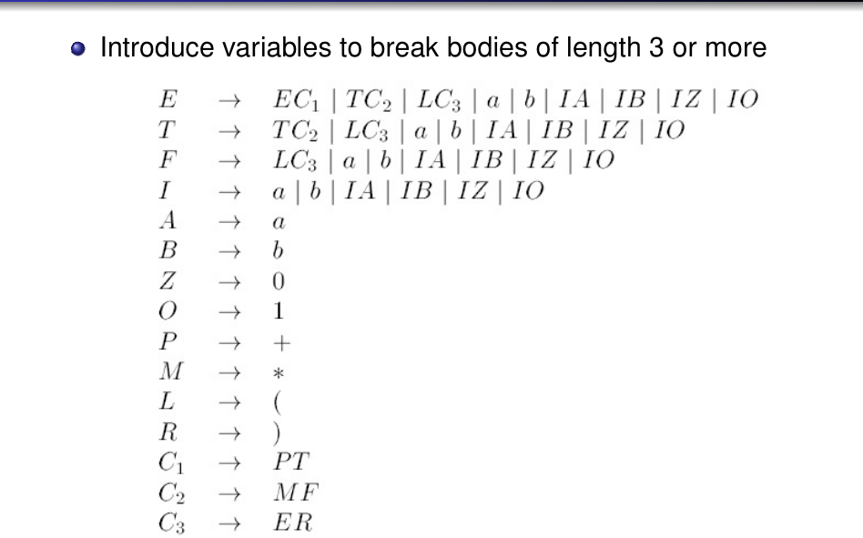
Figure 3.2 — Breaking bodies of length 3 with C1 → PT, C2 → MF, C3 → ER (sl. 35)
A body X1X2…Xk (k ≥ 3) becomes A → X1C1, C1 → X2C2, …, C(k−2) → X(k−1)Xk.

Exam Approach
1. Write the original language in one line if easy — it helps you check the result.
2. Do steps 1–3 exactly as in Lesson 2, showing the grammar after each.
3. New variables for terminals (Z → 0, U → 1); new variables for long bodies.
4. Check: every rule is A → BC or A → a (plus S → ε if ε ∈ L); derive one short string.
TRAP Never leave A → ε or A → B in the final grammar; never replace a lone terminal body A → 0 by a variable; keep ε only as S → ε for the (new) start symbol.

Practice — Lesson 3
(a) Actual — 2021-22 Q5 / 2017-18 Q7(a). (b) Actual — 2016-17 Q6(b) / 2014-15 Q5(c).
(a) Convert S → A1A | B, A → 0A | 1A | ε, D → 00 (2017-18; in 2021-22 the last rule is B → 1) into an equivalent grammar in CNF. Show the steps. (8–15)
(b) What is CNF? Convert A → BAB | B | ε, B → 00 | ε into an equivalent grammar in CNF. (9⅓–10)

✔ Solution
(a) L(G) = binary strings containing at least one 1 (S → A1A, A = (0 ∪ 1)∗).
Step 1 (ε): nullable A. S → A1A | 1A | A1 | 1 | B A → 0A | 0 | 1A | 1 D → 00 (2021-22: B → 1)
Step 2 (unit): unit pair (S,B). 2017-18: B has no productions → S → B simply disappears.
2021-22: S → B, B → 1 gives S → 1 (already present).
Step 3 (useless): B is not generating (2017-18); D is not reachable (2017-18). Remove both.
S → A1A | 1A | A1 | 1 A → 0A | 1A | 0 | 1
Step 4a: Z → 0, U → 1. S → AUA | UA | AU | 1 A → ZA | UA | 0 | 1
Step 4b: S → AUA becomes S → VA, V → AU.
CNF: S → VA | UA | AU | 1 V → AU A → ZA | UA | 0 | 1 Z → 0 U → 1

Checked: the CNF grammar generates exactly the strings with at least one 1 (all strings up to length 7).
(b) CNF definition: Lesson 3 box. L = {(00)^k | k ≥ 0} — note ε ∈ L.
Step 1 (ε): nullable A, B. A → BAB | AB | BA | BB | B | A (drop A → A) B → 00
ε ∈ L → new start S0 → A | ε
Step 2 (unit): A → B gives A → 00; S0 → A gives S0 → (all A bodies)
S0 → BAB | AB | BA | BB | 00 | ε A → BAB | AB | BA | BB | 00 B → 00
Step 3 (useless): none.
Step 4a: Z → 0: …… 00 becomes ZZ
Step 4b: BAB becomes BC with C → AB
CNF: S0 → BC | AB | BA | BB | ZZ | ε A → BC | AB | BA | BB | ZZ C → AB B → ZZ Z → 0

Checked: the CNF grammar (with S0 → ε) generates exactly (00)∗ up to length 8.

Lesson 4 — The CYK Membership Algorithm
Lecture 2, slides 4–18
CYK (Cocke–Younger–Kasami) decides w ∈ L(G) for a CNF grammar G in O(n³) time by dynamic programming (sl. 4). X_{ij} = set of variables A with A ⇒∗ a_{i}…a_{j} (sl. 8); w ∈ L iff S ∈ X_{1n} (sl. 9).
X_{ii} = { A | A → a_{i} }
A ∈ X_{ij} ⇔ ∃k, i ≤ k < j, B ∈ X_{ik}, C ∈ X_{k+1,j}, A → BC
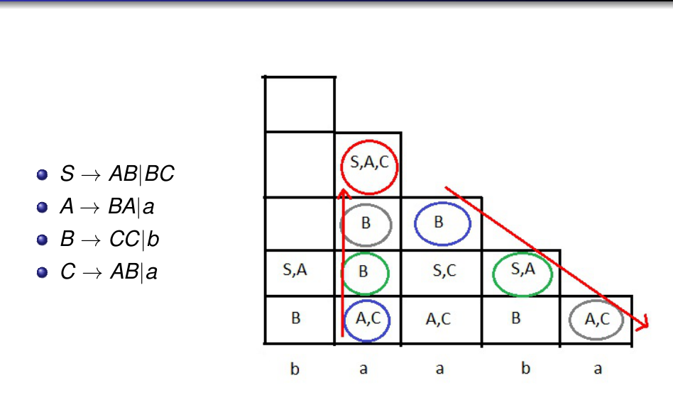
Figure 4.1 — How X_{ij} is computed: pair the cells below and diagonally (sl. 17)

Worked Example: baaba (sl. 11–18)
S → AB | BC A → BA | a B → CC | b C → AB | a

len 5: X15={A,C,S}
len 4: X14=∅ X25={A,C,S}
len 3: X13=∅ X24={B} X35={B}
len 2: X12={A,S} X23={B} X34={C,S} X45={A,S}
len 1: X11={B} X22={A,C} X33={A,C} X44={B} X55={A,C}
b a a b a
S ∈ X15 ⇒ baaba ∈ L(G)

Exam Approach
1. Bottom row: for each symbol the variables with A → symbol.
2. Row of length L: for each cell try every split k; for each pair (B in left cell, C in right cell) collect the heads A → BC. Write the pairs you tried in rough work.
3. Top cell: answer 'w ∈ L(G)' iff S is in it.
4. If asked to describe L(G), read the CNF rules backwards into a familiar grammar.
TRAP X_{ij} uses ALL splits k = i … j−1, not only the middle one. A missing variable in a low row propagates upward — double-check the bottom two rows.

Practice — Lesson 4
(a) Actual — 2023-24 Q6, 2019-20 Q7, Jan-2020 Q7. (b) Actual — 2022-23 Q7. (c) Actual — 2017-18 Q7(b). (d) Actual — 2007-08 Q13.
(a) G (CNF): S → BZ | CY | ZZ | YY, B → ZA, C → YA, A → ZA | YA | 0 | 1, Z → 0, Y → 1. Using CYK determine whether 0010 (2023-24), 01100 (2019-20), 10011 (Jan-2020) is in L(G). Describe L(G). (15)
(b) G: S → AB | AY | YA | 1, A → ZA | YA | 0 | 1, B → YA, Z → 0, Y → 1. Is 0100 in L(G)? (15)
(c) Using the CNF grammar of Lesson 3 (a), is 01101 in the language? (7)
(d) CNF definition; CYK for abaab with S → AB | BC, A → BA | a, B → CC | b, C → AB | a. (10)

✔ Solution
(a) A ⇒∗ any non-empty binary string (A → ZA | YA | 0 | 1); B ⇒ 0A, C ⇒ 1A. So S → BZ = 0(0|1)⁺0, CY = 1(0|1)⁺1, ZZ = 00, YY = 11: L(G) = binary strings of length ≥ 2 whose first and last symbols are equal (checked by program). Tables:
len 4: X14={A,B,S}
len 3: X13={A,B} X24={A,B,S}
len 2: X12={A,B,S} X23={A,B} X34={A,C}
len 1: X11={A,Z} X22={A,Z} X33={A,Y} X44={A,Z}
0 0 1 0
S ∈ X14 ⇒ 0010 ∈ L(G)

len 5: X15={A,B,S}
len 4: X14={A,B,S} X25={A,C}
len 3: X13={A,B} X24={A,C} X35={A,C}
len 2: X12={A,B} X23={A,C,S} X34={A,C} X45={A,B,S}
len 1: X11={A,Z} X22={A,Y} X33={A,Y} X44={A,Z} X55={A,Z}
0 1 1 0 0
S ∈ X15 ⇒ 01100 ∈ L(G)

len 5: X15={A,C,S}
len 4: X14={A,C,S} X25={A,B}
len 3: X13={A,C} X24={A,B} X35={A,B}
len 2: X12={A,C} X23={A,B,S} X34={A,B} X45={A,C,S}
len 1: X11={A,Y} X22={A,Z} X33={A,Z} X44={A,Y} X55={A,Y}
1 0 0 1 1
S ∈ X15 ⇒ 10011 ∈ L(G)

(b)
len 4: X14={A,S}
len 3: X13={A,S} X24={A,B,S}
len 2: X12={A,S} X23={A,B,S} X34={A}
len 1: X11={A,Z} X22={A,S,Y} X33={A,Z} X44={A,Z}
0 1 0 0
S ∈ X14 ⇒ 0100 ∈ L(G)

L(G): S → AY | YA | AB … gives non-empty strings containing a 1 in a suitable position; CYK only needs the table.
(c) CNF: S → VA | UA | AU | 1, V → AU, A → ZA | UA | 0 | 1, Z → 0, U → 1.
len 5: X15={A,S,V}
len 4: X14={A,S} X25={A,S,V}
len 3: X13={A,S,V} X24={A,S} X35={A,S,V}
len 2: X12={A,S,V} X23={A,S,V} X34={A,S} X45={A,S,V}
len 1: X11={A,Z} X22={A,S,U} X33={A,S,U} X44={A,Z} X55={A,S,U}
0 1 1 0 1
S ∈ X15 ⇒ 01101 ∈ L(G)

(d) CNF definition: Lesson 3.
len 5: X15={C,S}
len 4: X14={A,S} X25=∅
len 3: X13={B} X24=∅ X35={B}
len 2: X12={C,S} X23={A,S} X34={B} X45={C,S}
len 1: X11={A,C} X22={B} X33={A,C} X44={A,C} X55={B}
a b a a b
S ∈ X15 ⇒ abaab ∈ L(G)

Quick Notes — Intro & CNF
Revision points for Lessons 1–4.

L1 · Areas
- Automata (models) · computability (solvable?) · complexity (efficiently?).
- FA ⊂ CFG/PDA ⊂ TM in power; TM simulates a computer.

L2 · Simplification
- Useless = not generating or not reachable; remove generating-failures first.
- Nullable: add all versions with nullable symbols dropped; keep S → ε only if ε ∈ L.
- Unit pairs (A, B): copy B's non-unit bodies to A; delete unit rules.

L3 · CNF
- A → BC | a, no useless symbols (+ S → ε).
- Order: ε → unit → useless → terminals → break long bodies.
- S → A1A | B, A → 0A|1A|ε ⇒ S → VA|UA|AU|1, V → AU, A → ZA|UA|0|1.
- A → BAB|B|ε, B → 00|ε ⇒ (00)∗; S0 → BC|AB|BA|BB|ZZ|ε, C → AB, B → ZZ.

L4 · CYK
- X_{ii} from A → a; X_{ij} from all splits; w ∈ L iff S ∈ X_{1n}; O(n³).
- S → BZ|CY|ZZ|YY grammar = length ≥ 2, first = last symbol (asked 3×).

Key Diagrams to Reproduce
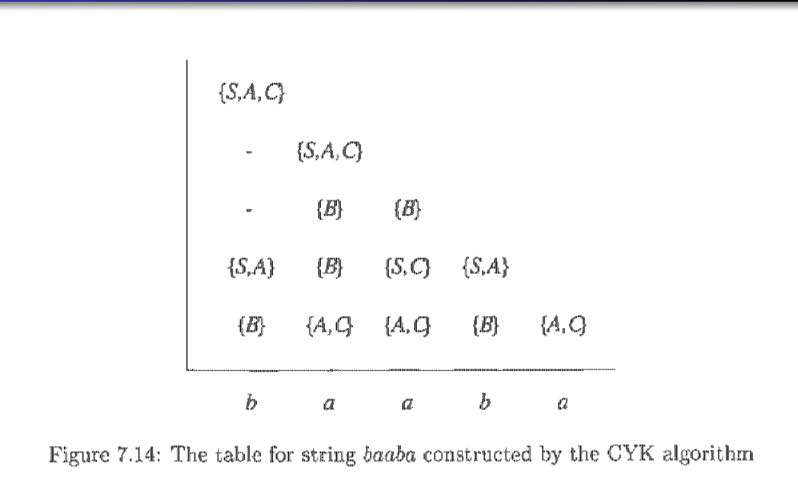
CYK table for baaba (sl. 18)

